**TESTNG ASSIGNMENT**

**Q) Please do the following assignment for TestNG framework -**

**1. Install TestNG**

A1) Added TestNG dependency from Maven repository

<dependency>

<groupId>org.testng</groupId>

<artifactId>testng</artifactId>

<version>7.8.0</version>

<scope>test</scope>

</dependency>

**2. Create a TestNG Project**

A2) created a project called “TestNGAssignments”

**3. Create 2 test classes (with 3 test cases each).**

**4. Keep the 2 test classes in 2 different <test> tags in testng.xml**

A3)

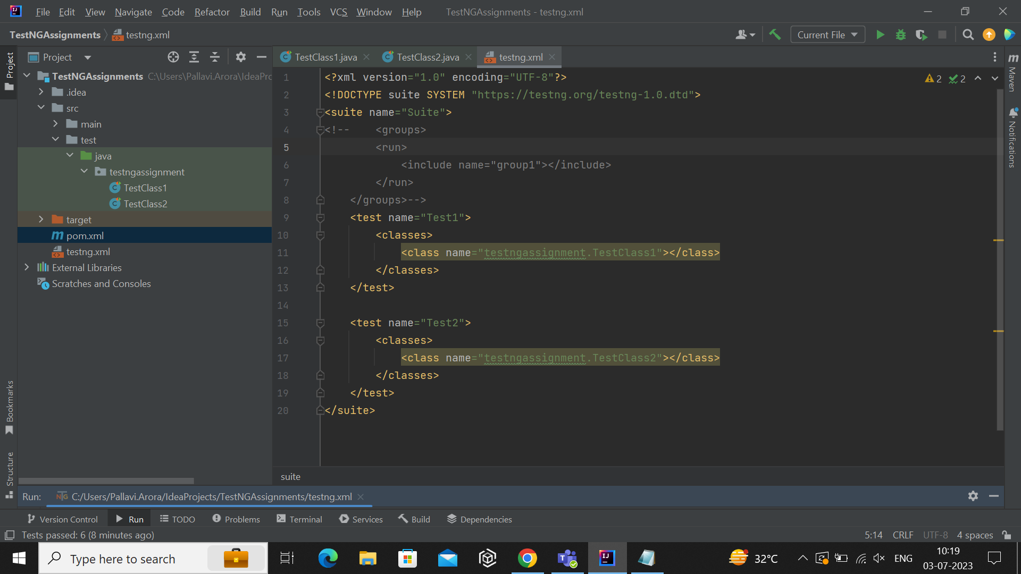

**5. Execute the tests above using testng.xml**

A5)

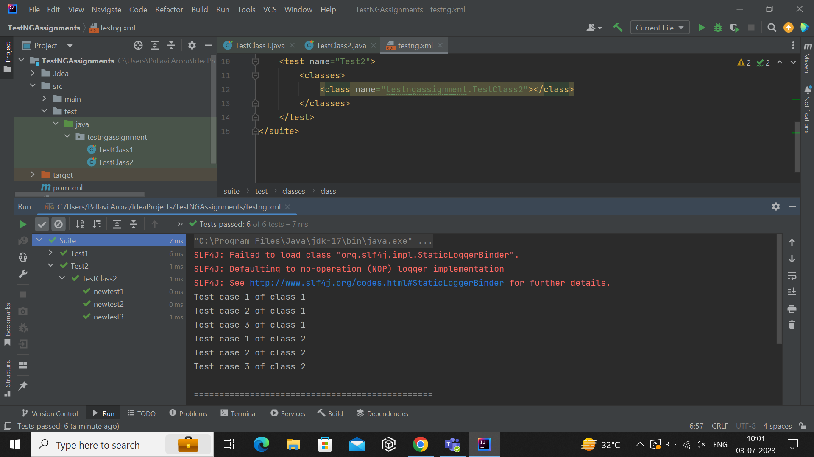

**6. Assign a group to a few test cases and update testng.xml to run test cases belonging to the group.**

A6)

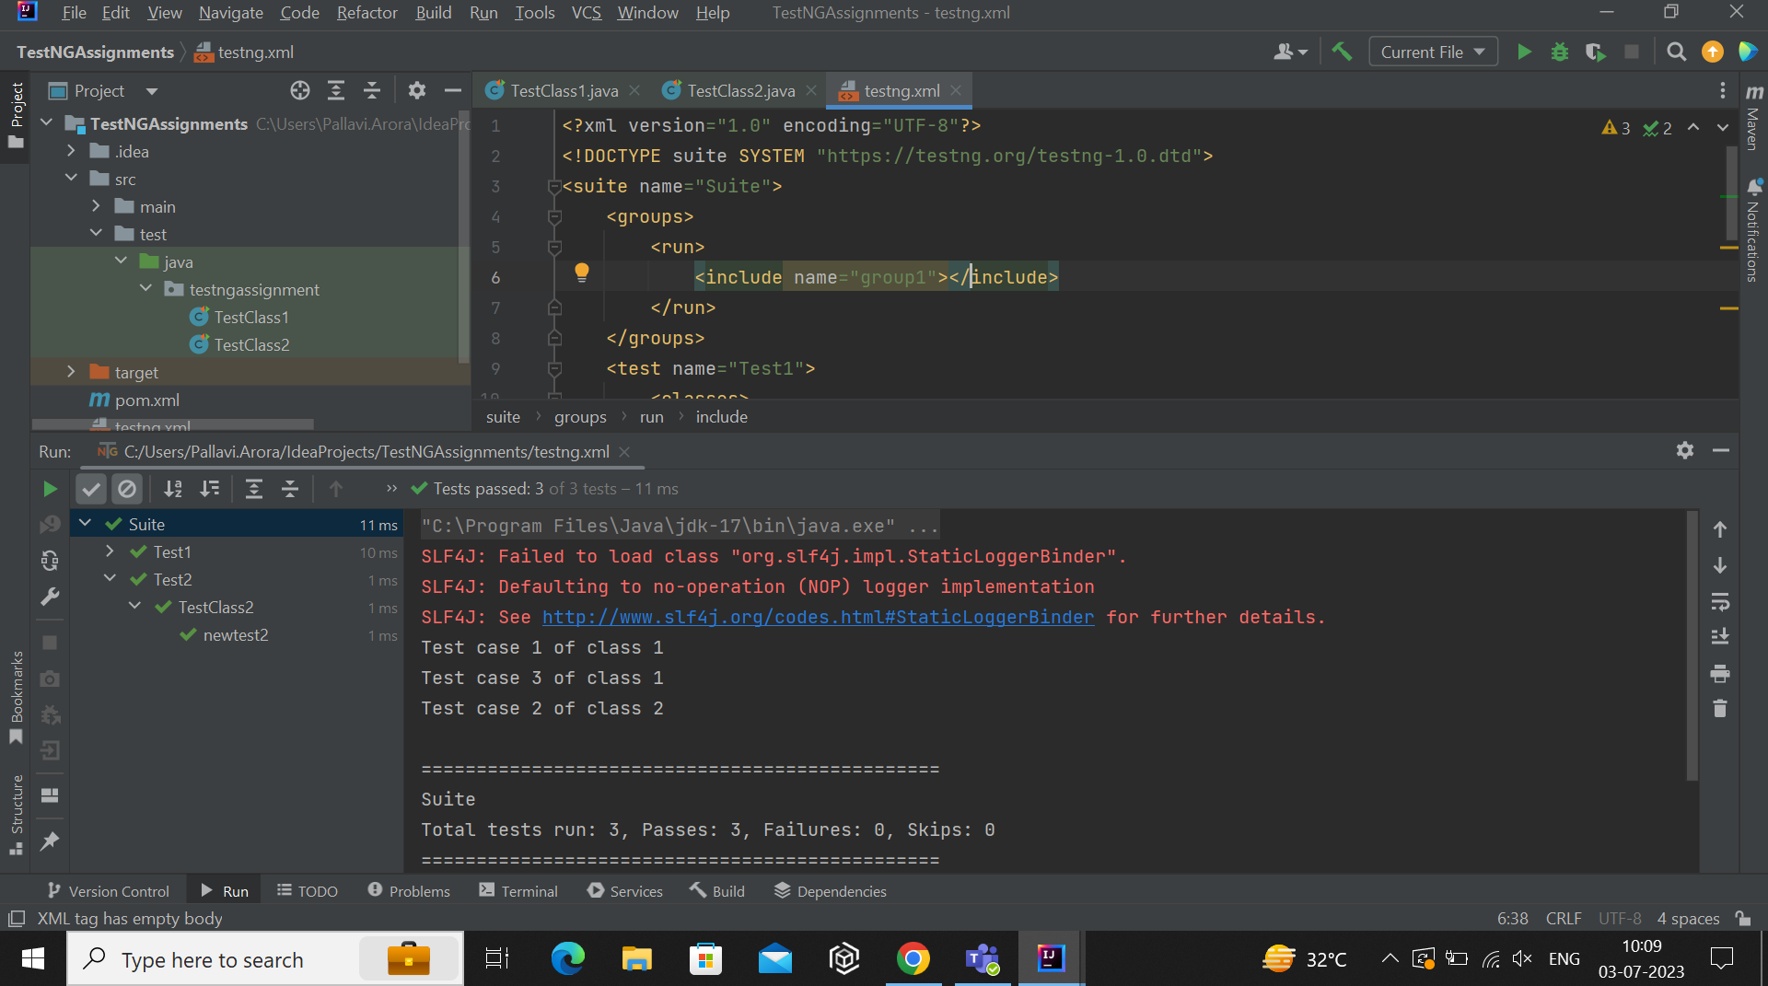

**7. Assign priority to the test cases.**

A7)

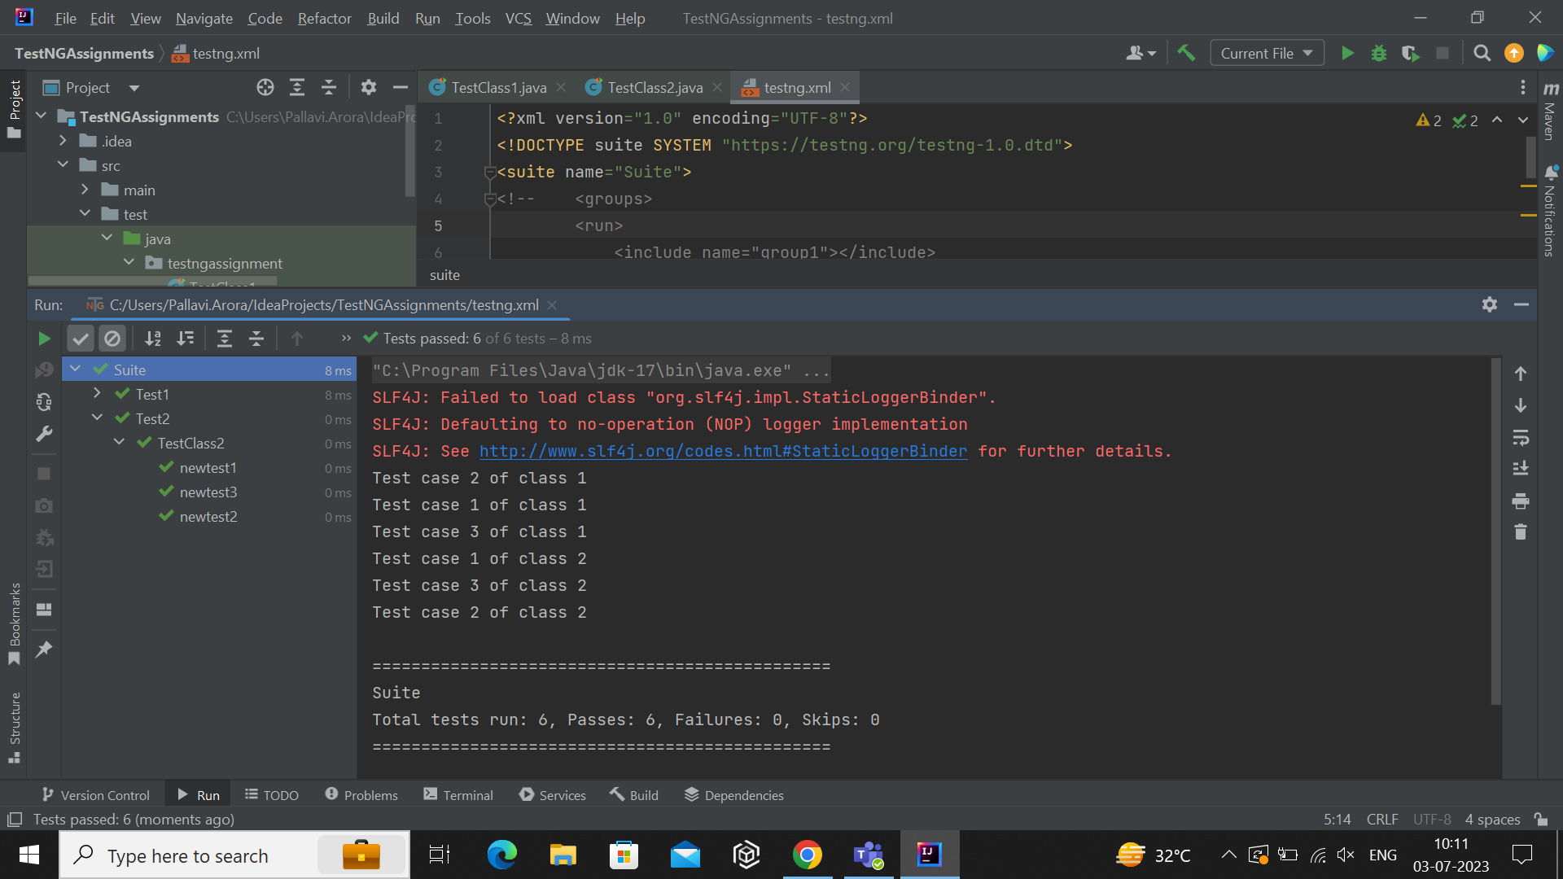

**Code :**

**TestClass1.java**

package testngassignment;

import org.testng.annotations.Test;

public class TestClass1 {

//creating test cases and giving priority

@Test (groups = {"group1"}, priority = 1)

public void test1() {

System.out.println("Test case 1 of class 1");

}

@Test (priority = 0)

public void test2() {

System.out.println("Test case 2 of class 1");

}

@Test (groups = {"group1"}, priority = 5)

public void test3() {

System.out.println("Test case 3 of class 1");

}

}

**TestClass2.java**

package testngassignment;

import org.testng.annotations.Test;

public class TestClass2 {

//creating test cases and giving priority

@Test (priority = 2)

public void newtest1() {

System.out.println("Test case 1 of class 2");

}

@Test (groups = {"group1"}, priority = 4)

public void newtest2() {

System.out.println("Test case 2 of class 2");

}

@Test (priority = 3)

public void newtest3() {

System.out.println("Test case 3 of class 2");

}

}

**testng.xml**

<?xml version="1.0" encoding="UTF-8"?>

<!DOCTYPE suite SYSTEM "https://testng.org/testng-1.0.dtd">

<suite name="Suite">

<!-- including group which we need to run-->

<!-- <groups>

<run>

<include name="group1"></include>

</run>

</groups>-->

<!-- class 1 in test tag-->

<test name="Test1">

<classes>

<class name="testngassignment.TestClass1"></class>

</classes>

</test>

<!-- class 2 in test tag-->

<test name="Test2">

<classes>

<class name="testngassignment.TestClass2"></class>

</classes>

</test>

</suite>